Program Structures and Algorithms

Spring 2023(SEC – 03)

NAME: Changyu Wu

NUID: 002111594

**Task:** **Assignment 6 (Hits as time predictor)**

**Conclusion:**

For sorting algorithms, hits are the best predictor of total execution time.

**Evidence to support that conclusion:**

The spreadsheet and graphs are recorded in the file “Hits_as_time_predictor.xlsx”.

Based on the experiments, swaps, comparisons, and copies can predict execution time well in some cases, such as Merge sort. But in some algorithms like Quicksort, only hits could predict well.

**Log/Log Graphical Representation:**

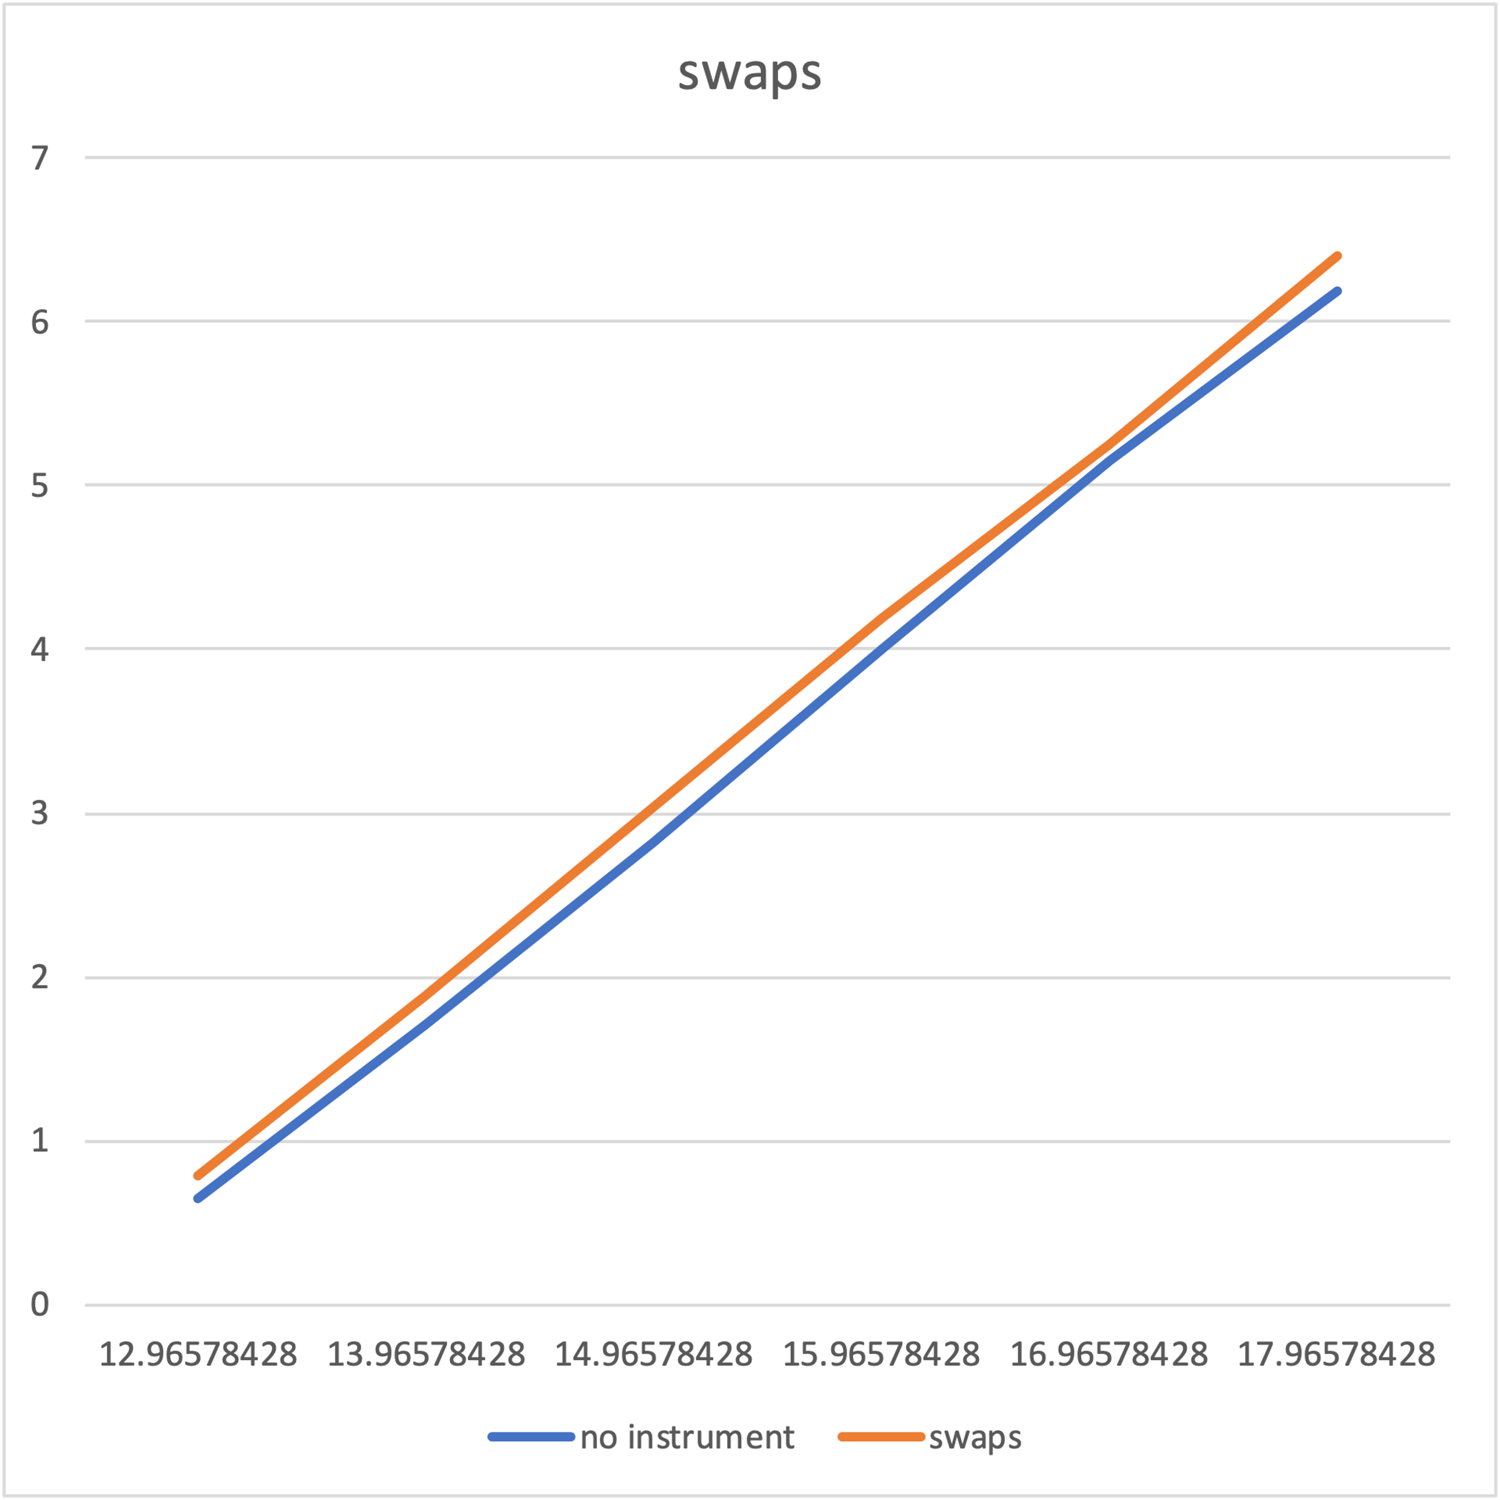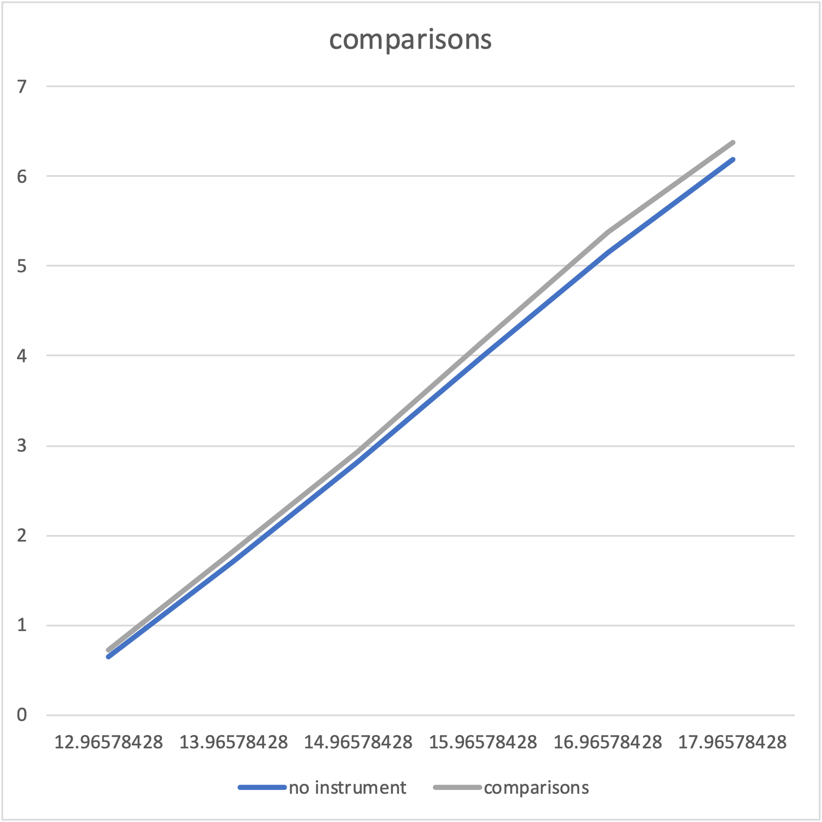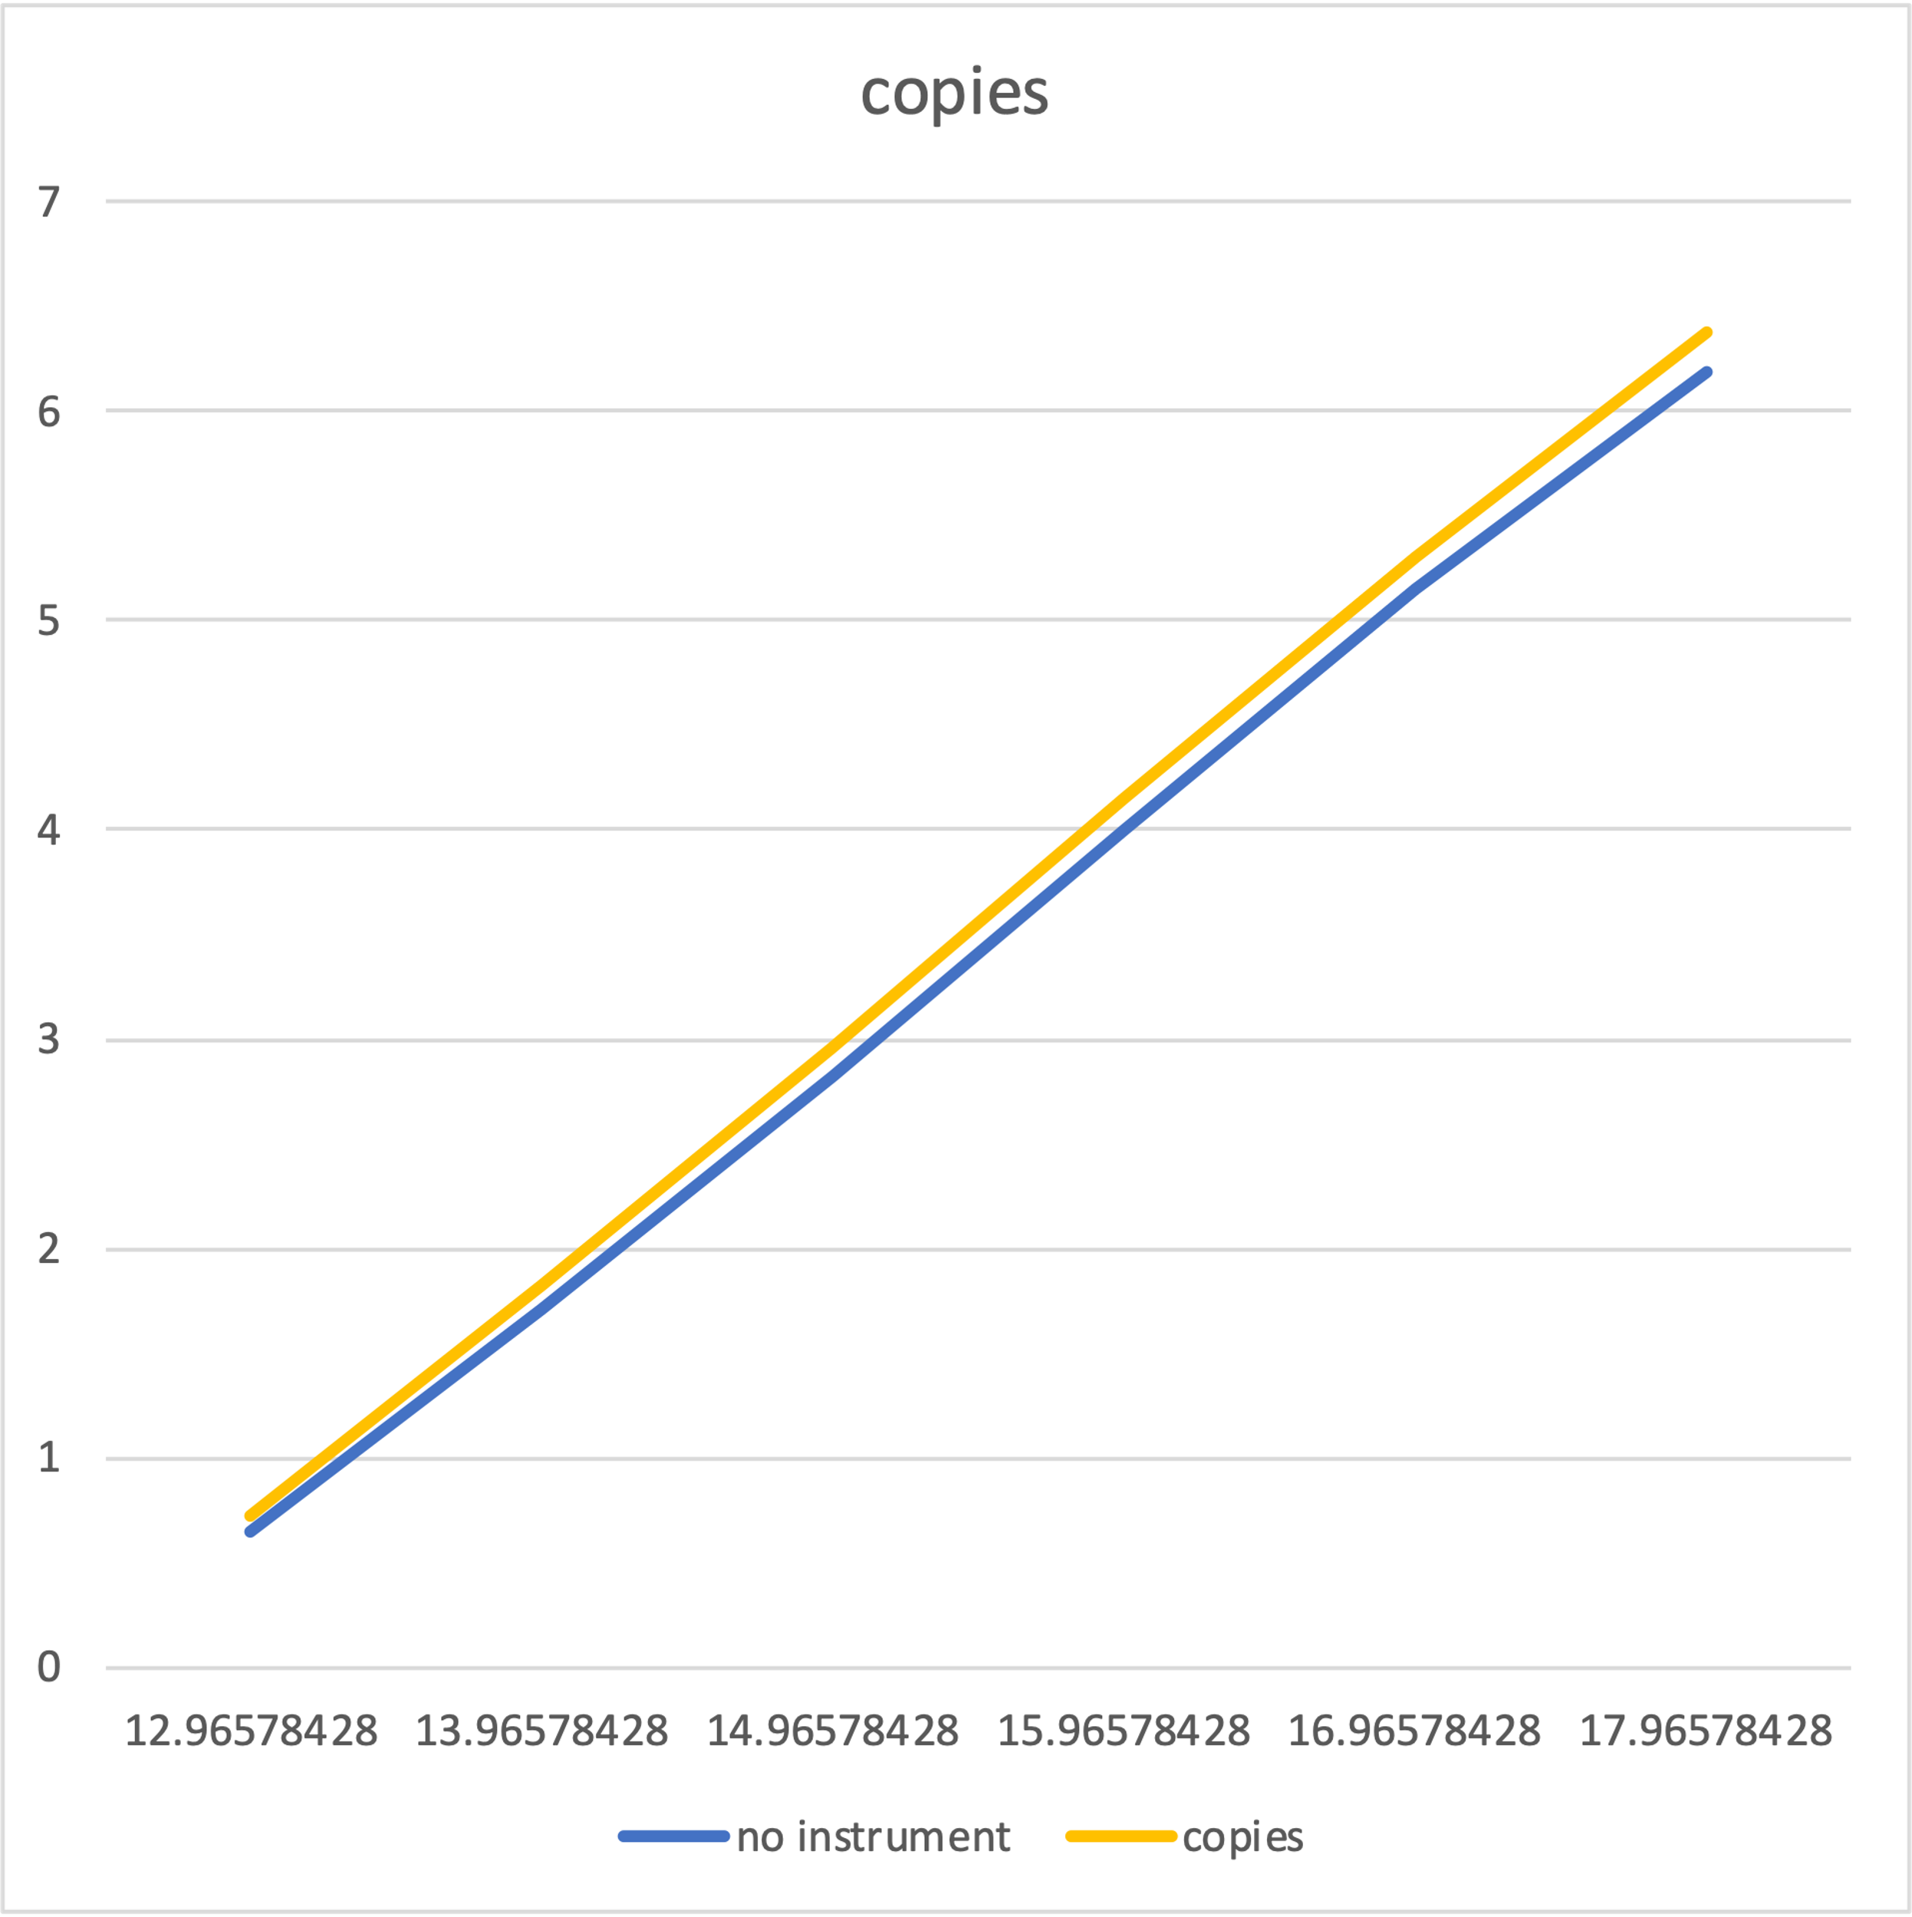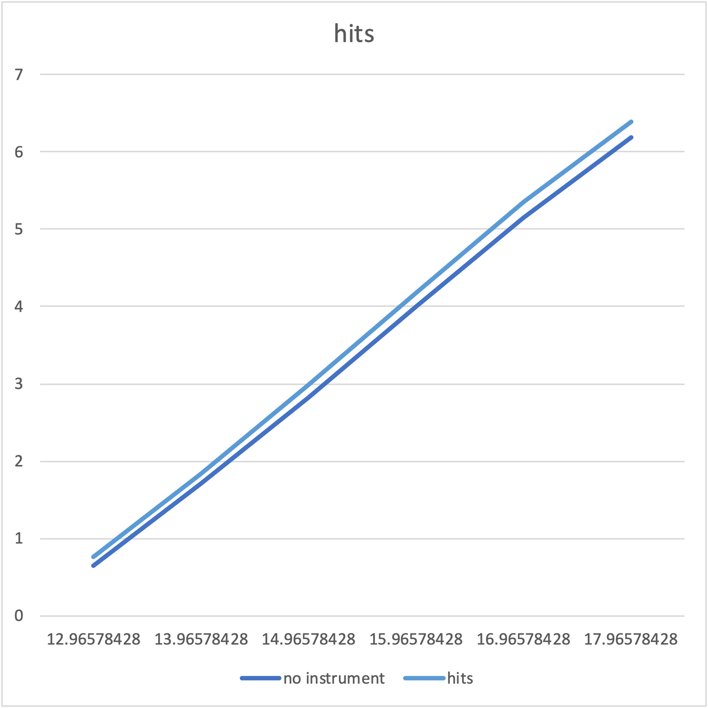

Merge Sort

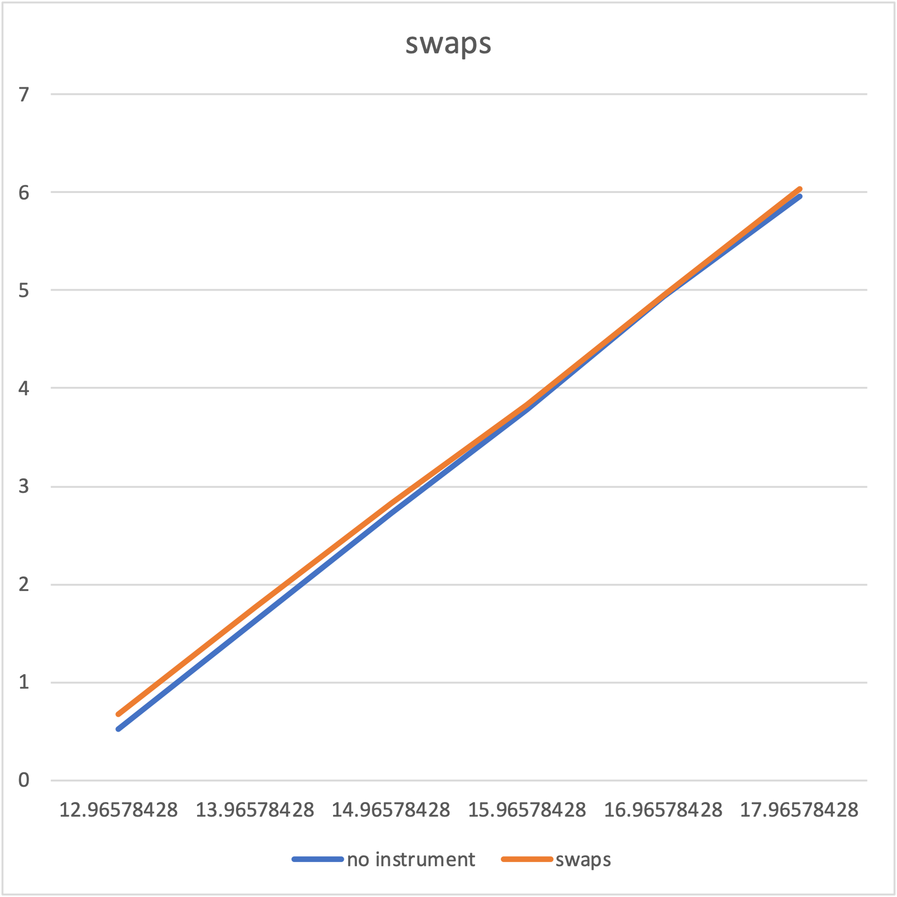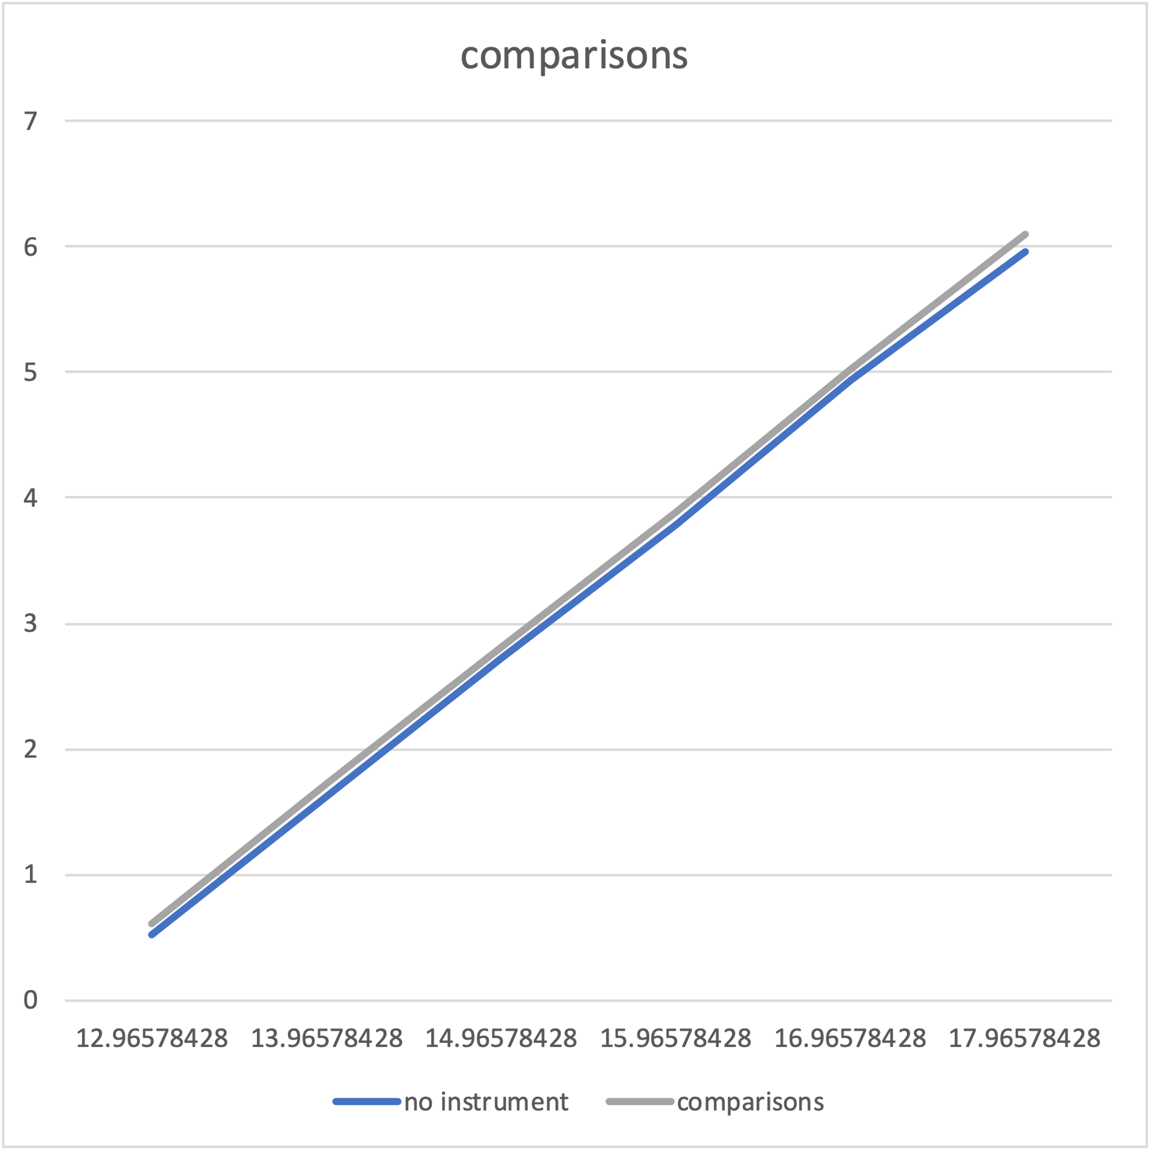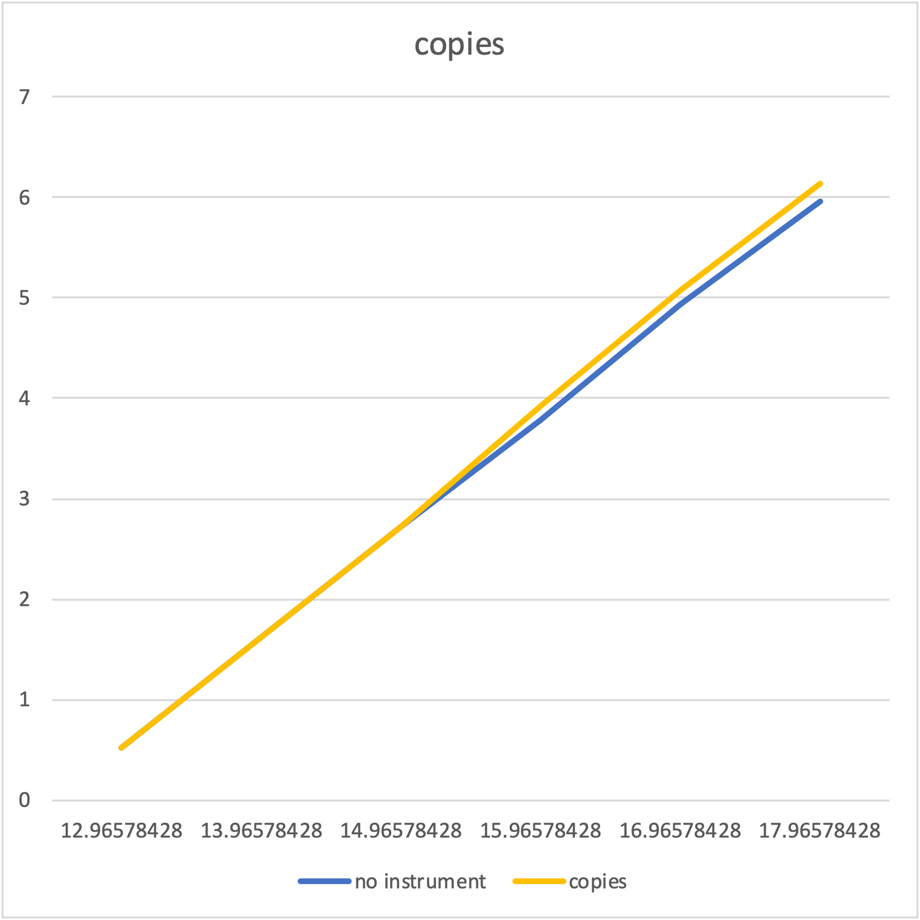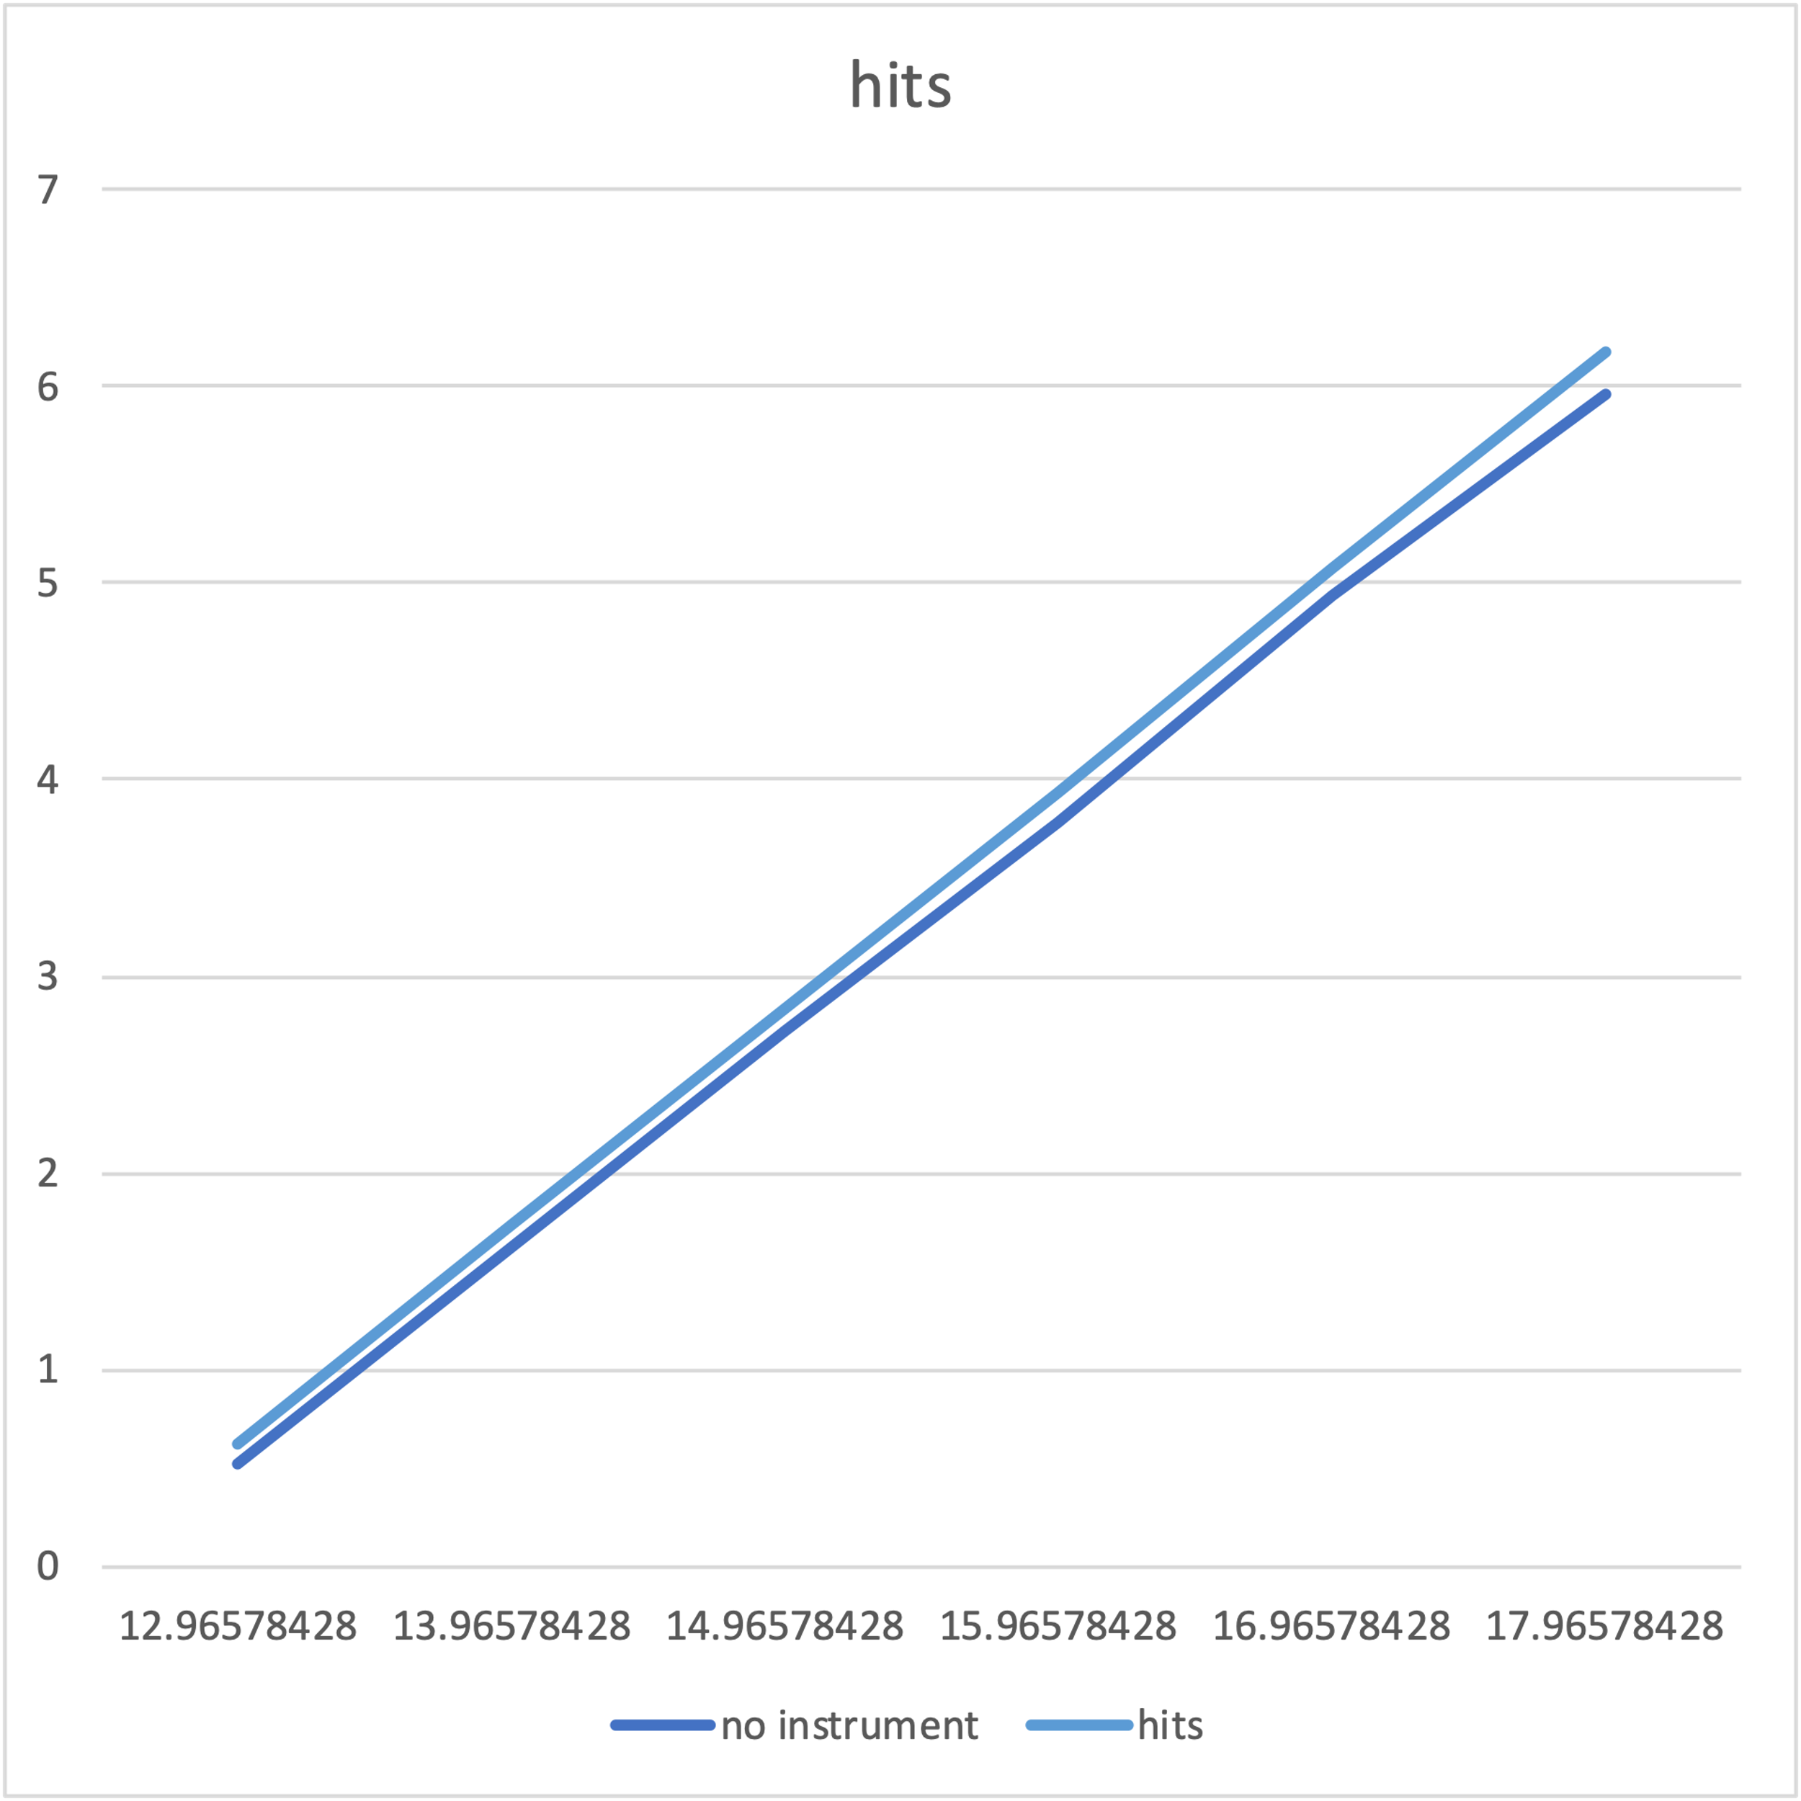

Quicksort Dual Pivot

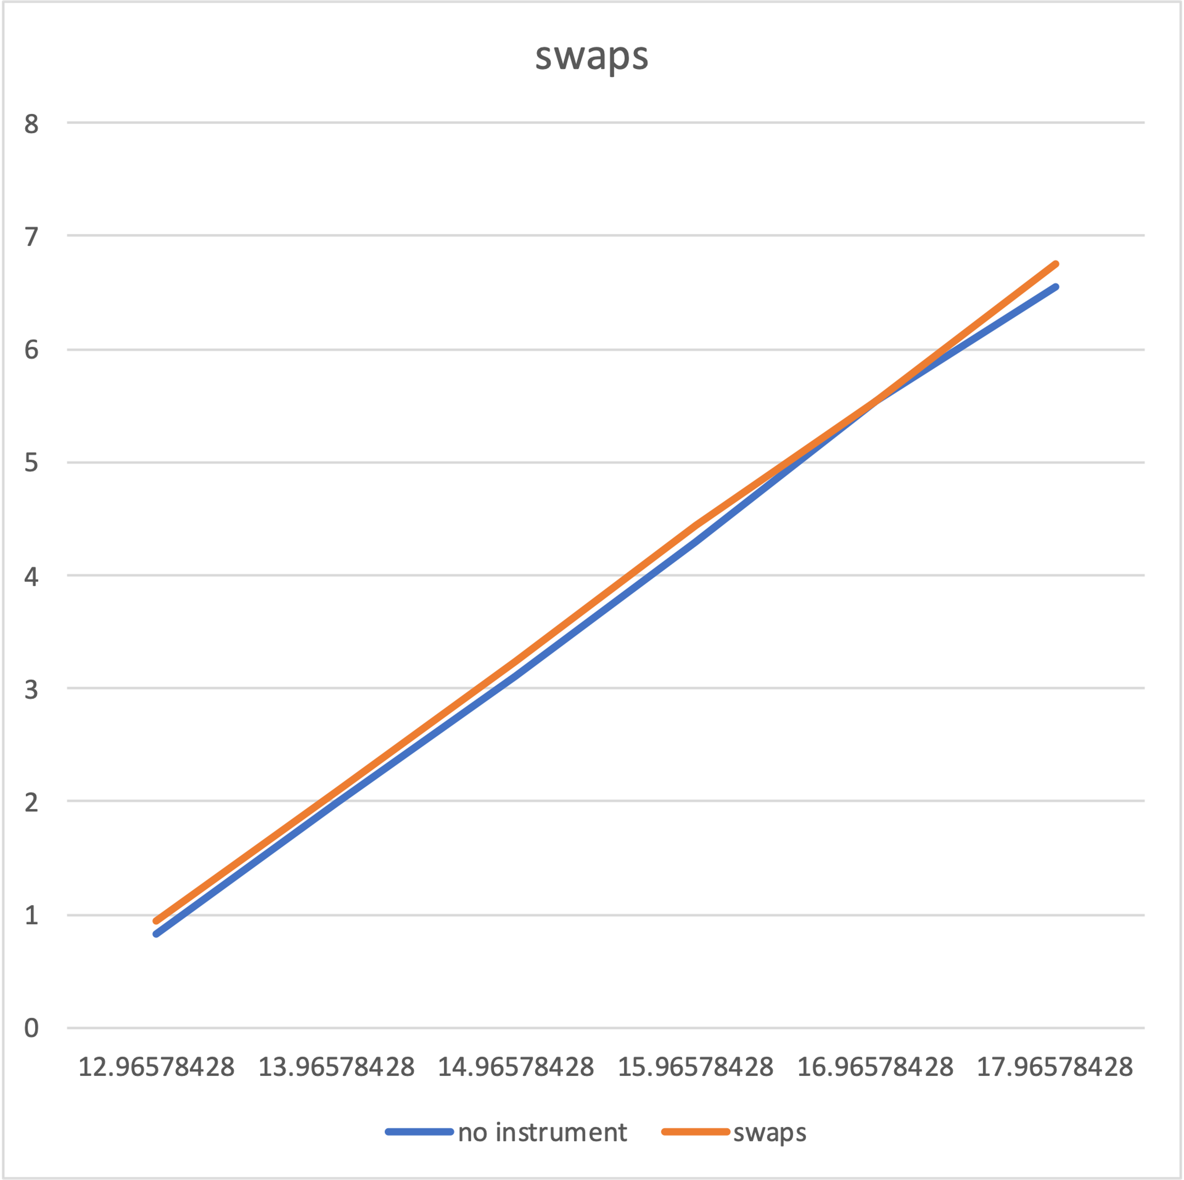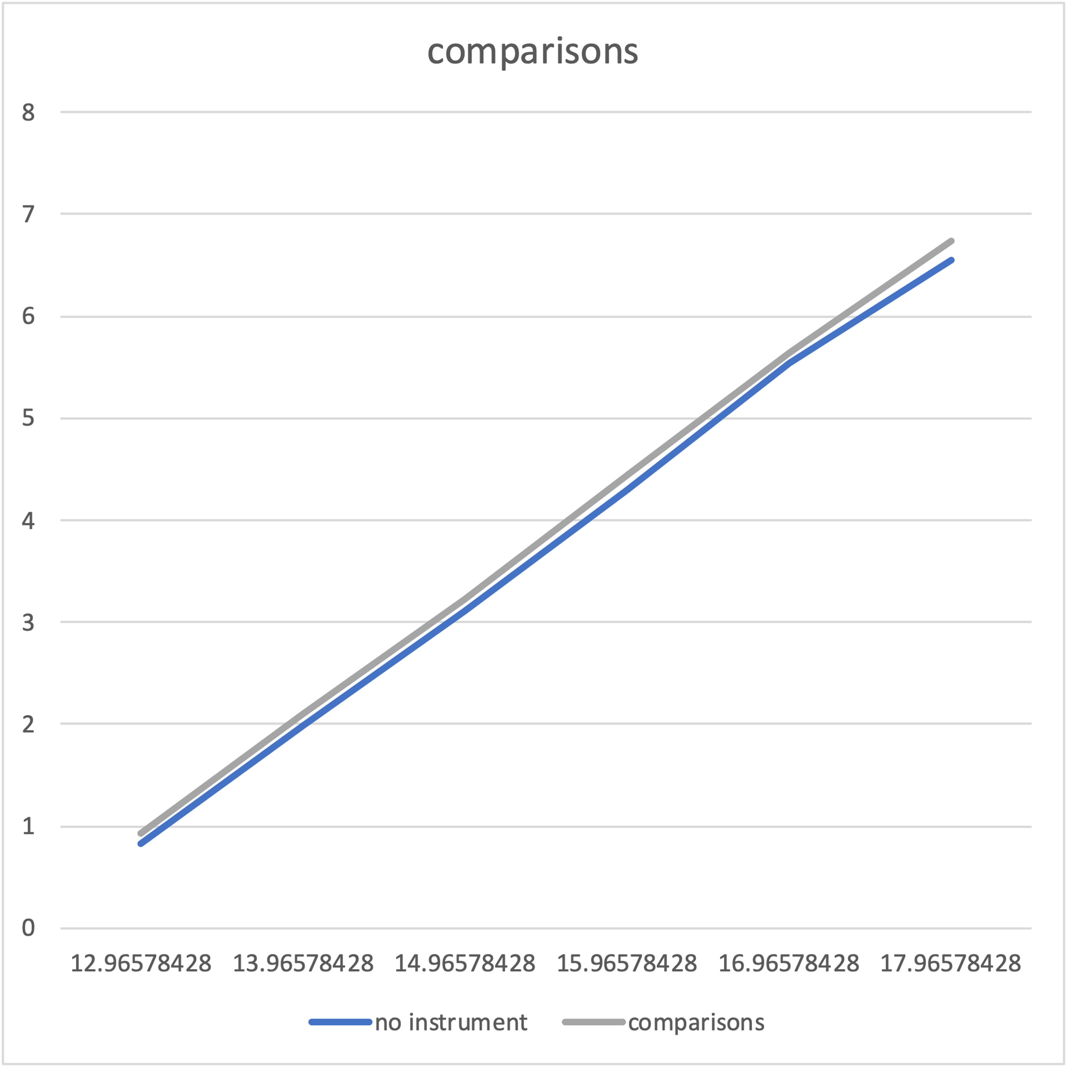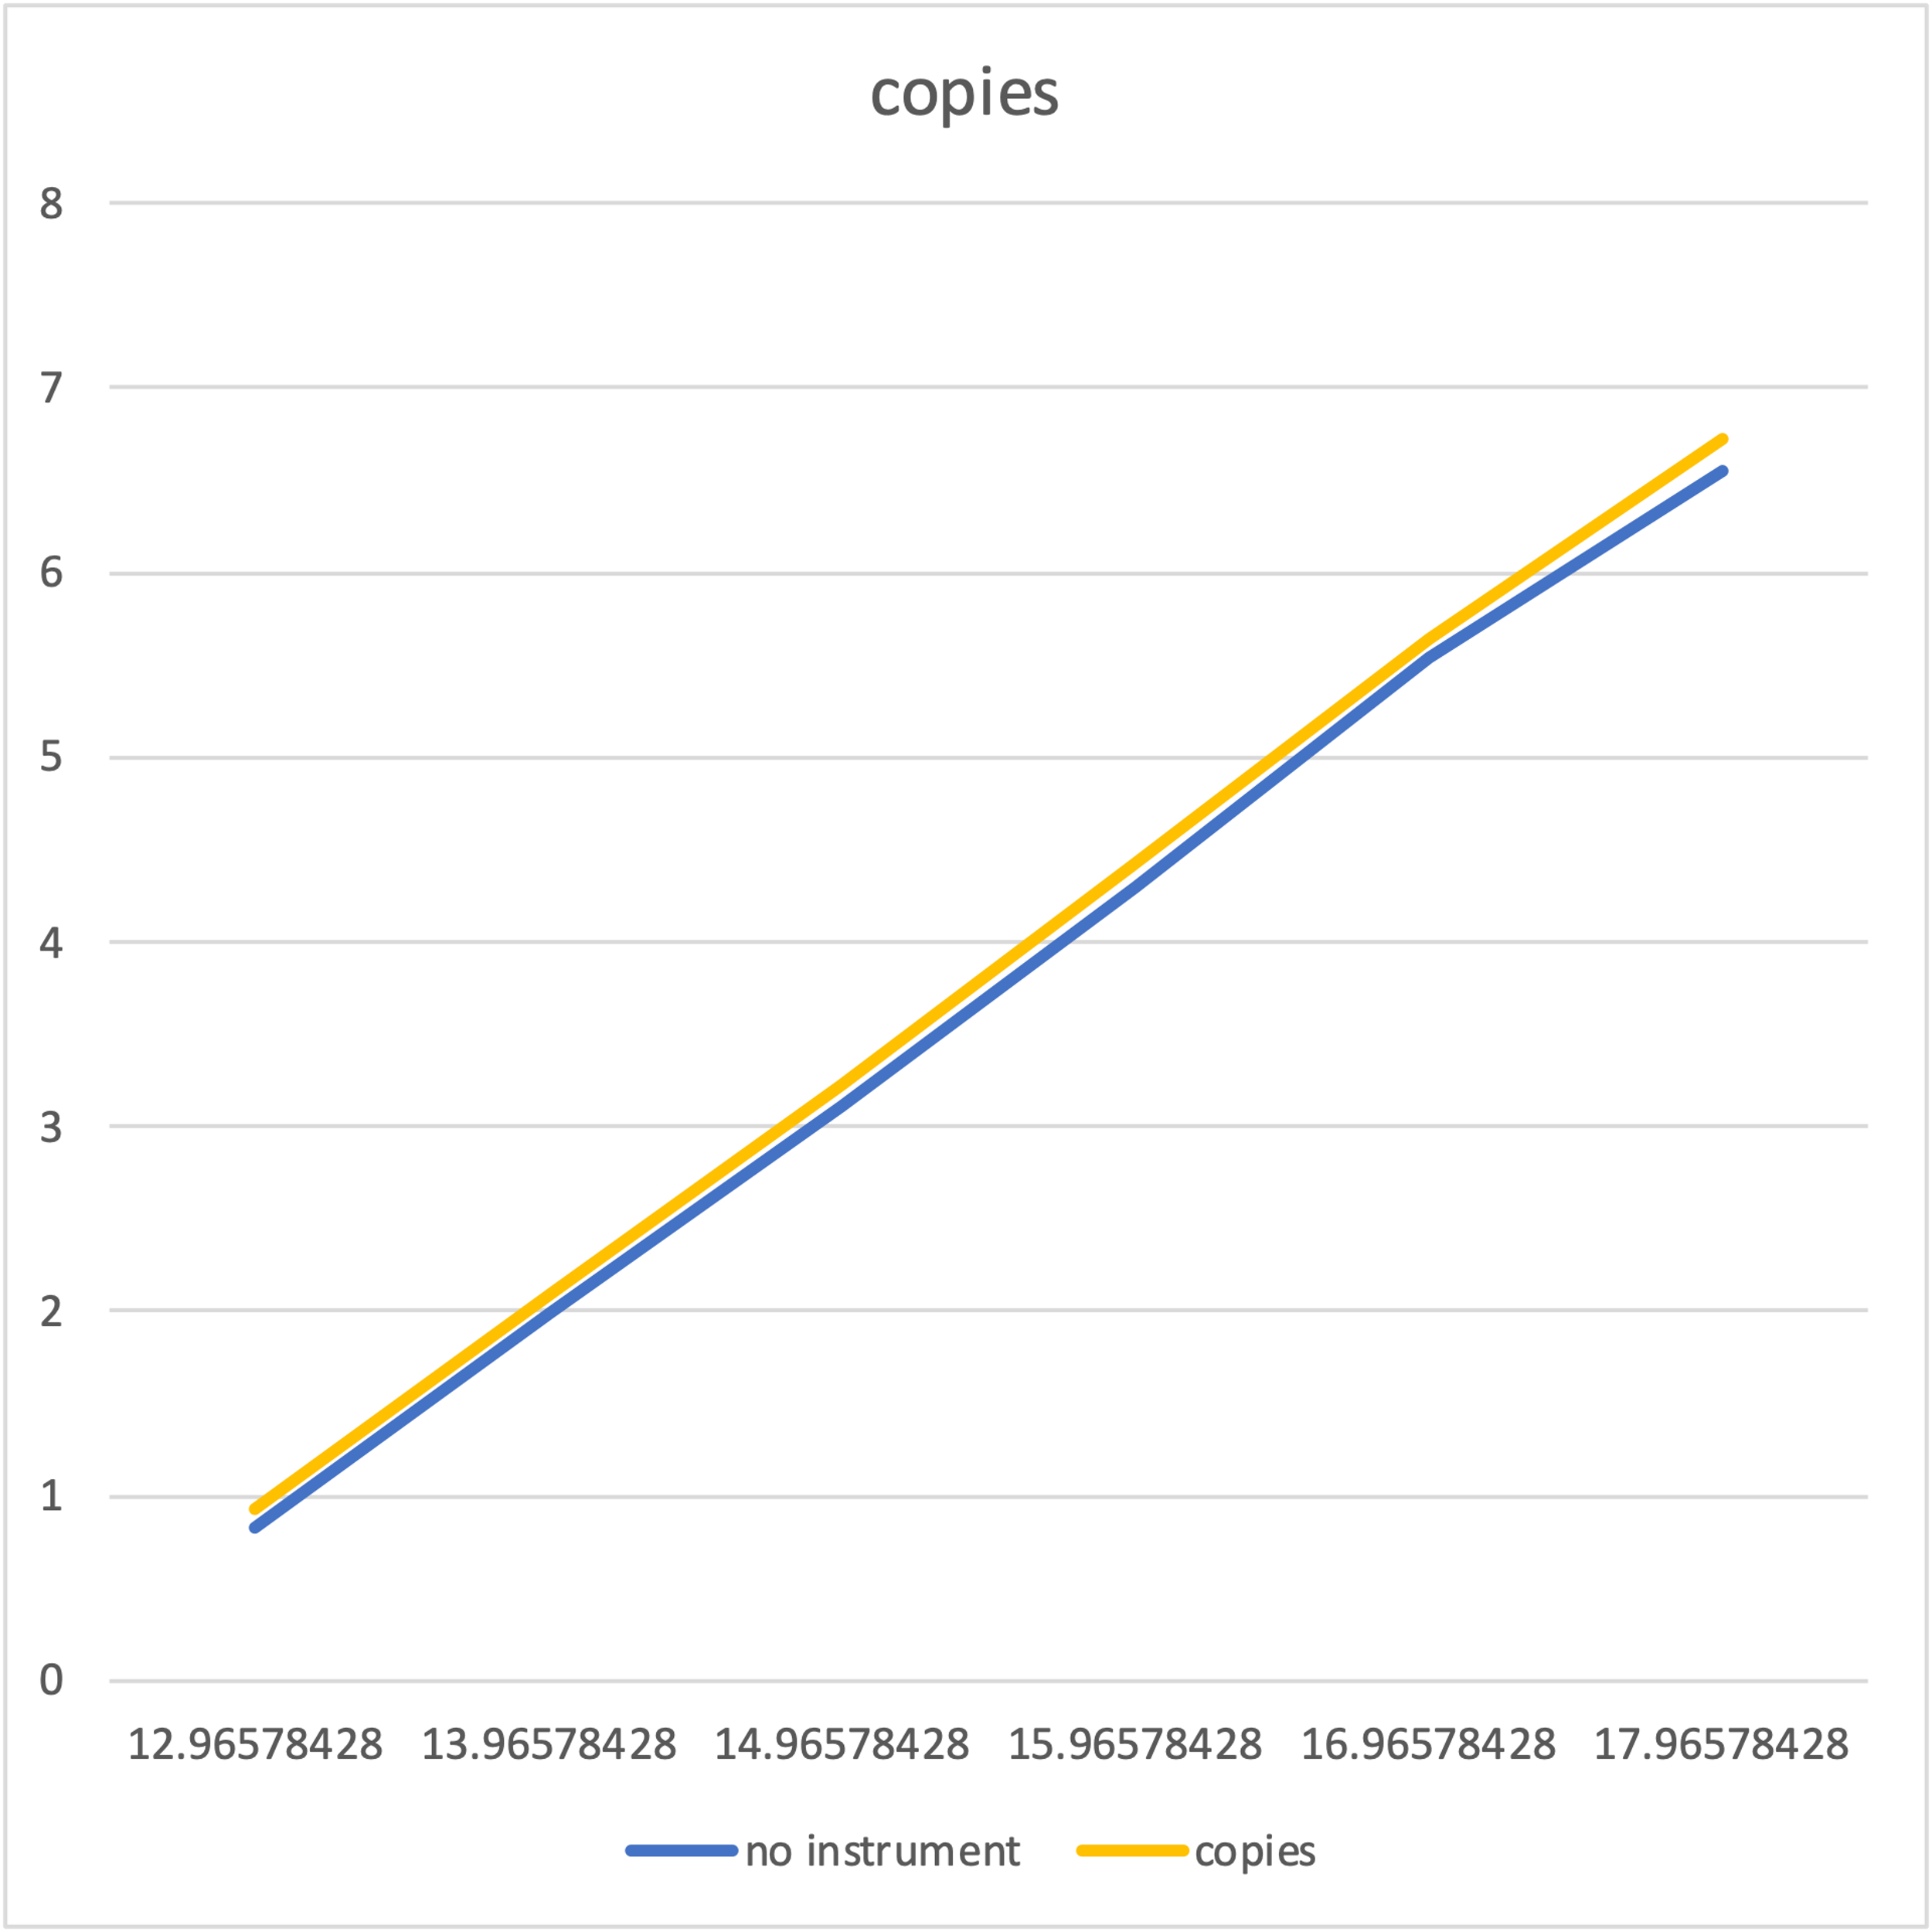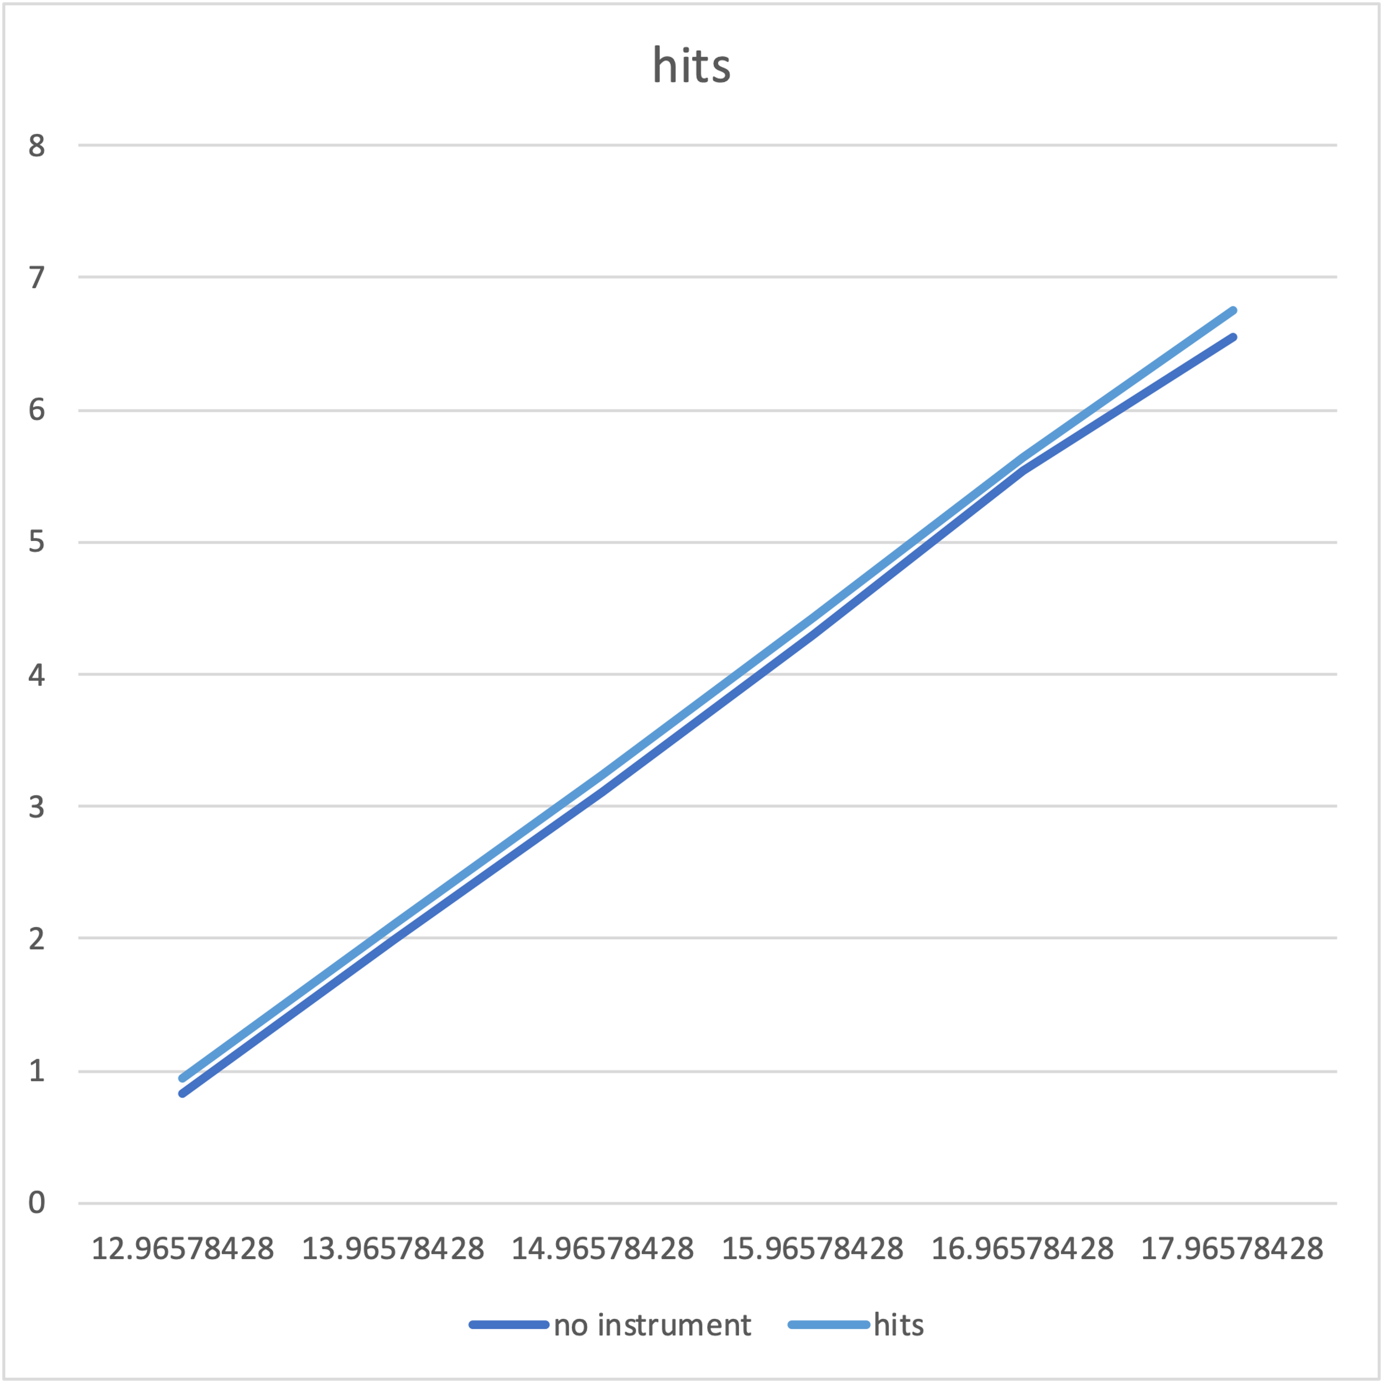

Heapsort